Task 1:

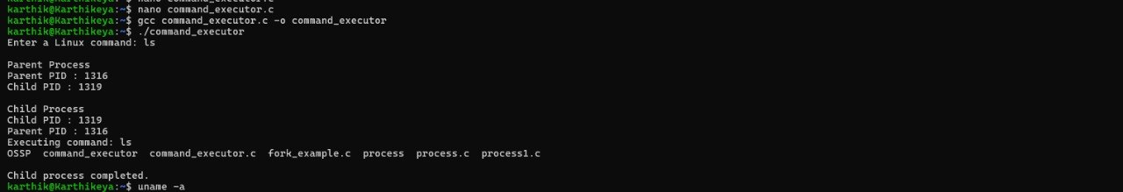

Task 2: Investigation of Hardware Resources and Operating System Services

Introduction
In this experiment, Linux terminal commands were used to study different hardware resources managed by the operating system. Commands such as uname -a, lscpu, ps, and top were executed to view system information, processor details, running processes, and system performance. This experiment helped in understanding how the operating system provides a simple way to interact with the computer hardware.

Command: uname -a

Output:
Explanation:
The uname -a command displays information about the operating system. From the output, it is observed that the system is running Ubuntu Linux on WSL2 with a 64-bit architecture. It also displays the kernel version and system information, which helps identify the operating system environment.

Command: lscpu

Output:
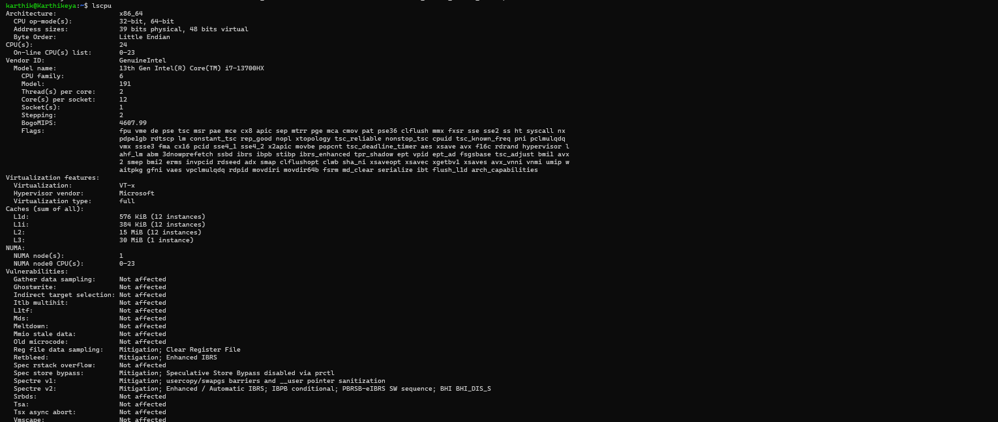

Explanation:
The lscpu command displays detailed information about the processor. The output shows that the system uses a 13th Gen Intel Core i7-13700HX processor with 24 logical CPUs. It also provides information about CPU architecture, cache memory, virtualization support, and processor features.

Command: ps

Output:
Explanation:
The ps command displays the processes currently running in the terminal session. In the output, the bash shell and the ps command itself are listed along with their Process IDs (PIDs).

Command: top

Output:
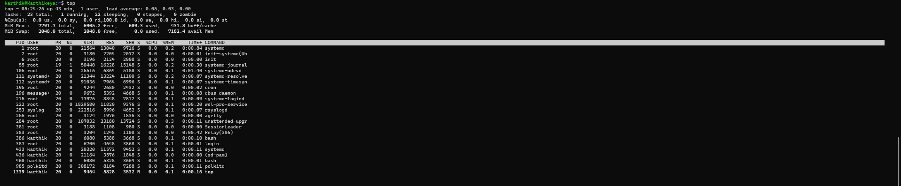

Explanation:
The top command displays the current status of the system in real time. It shows CPU usage, memory usage, running tasks, system load, and the processes currently executing.

Operating System Abstraction

CPU Abstraction
The operating system manages the CPU by deciding which process should run and for how long. This allows multiple programs to run one after another so quickly that they appear to run at the same time.

Memory Abstraction
The operating system allocates memory to each program whenever it is needed. Every process gets its own memory space, which helps prevent programs from interfering with each other.

Storage Abstraction
The operating system organizes data into files and folders. Users can easily access, create, or delete files without worrying about where the data is physically stored on the disk.

I/O Device Abstraction
The operating system communicates with hardware devices through device drivers. This allows applications to use devices like the keyboard, mouse, monitor, printer, and storage devices without directly interacting with the hardware.

Conclusion
By executing uname -a, lscpu, ps, and top, it was possible to study the operating system, processor details, running processes, and system performance. The experiment also showed how the operating system manages CPU, memory, storage, and input/output devices.

